NXP-MCUBootUtility User's Guide

For RT600 flash programming tool, NXP MCU Boot Utility is recommended. The address of the tool on GITHUB: <https://github.com/JayHeng/NXP-MCUBootUtility> . Support RT600 B0 version chip.

Please Use V2.2.0 release Version.

<https://github.com/JayHeng/NXP-MCUBootUtility/releases>

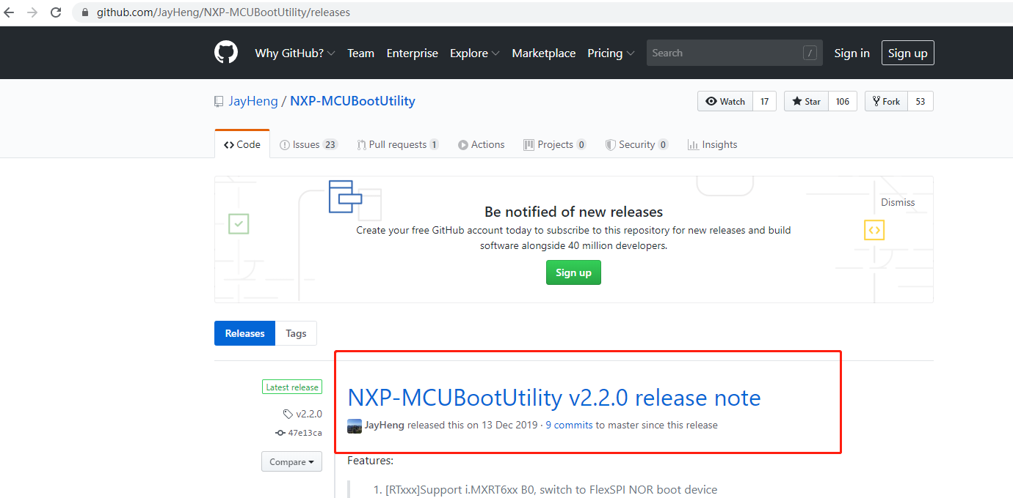

Before download, use a USB cable (Type-C) to connect the PC and the device.

Note: The USB cable needs to have d + / d-.

Step 1, import the hello word project and compile

Note1 : Setup project “Link application to RAM” , Select project, right-click, and select properties.

Known issues: The project has not enable the QSPI XIP function.

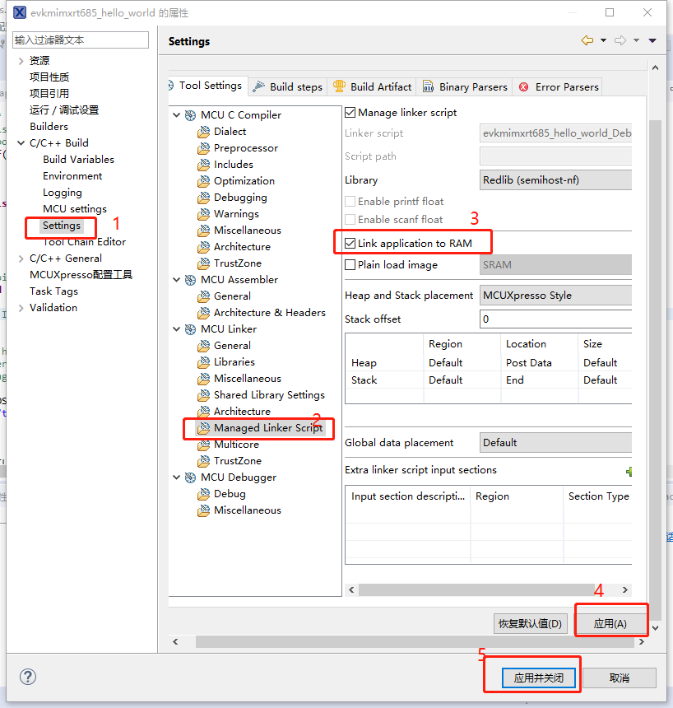

Select the project hardware UART output log

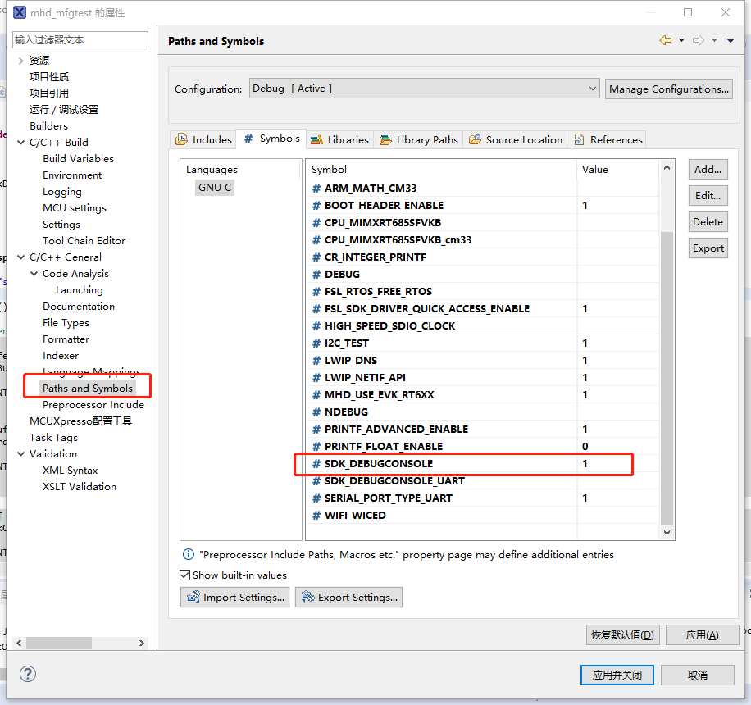

Step 2: Burning to board flash

1. ISP configure to 011, Connect the device to the PC using USB type-c.

In PC device manager, discover new HID devices, Right - click the device to view the device's VID and PID in the event

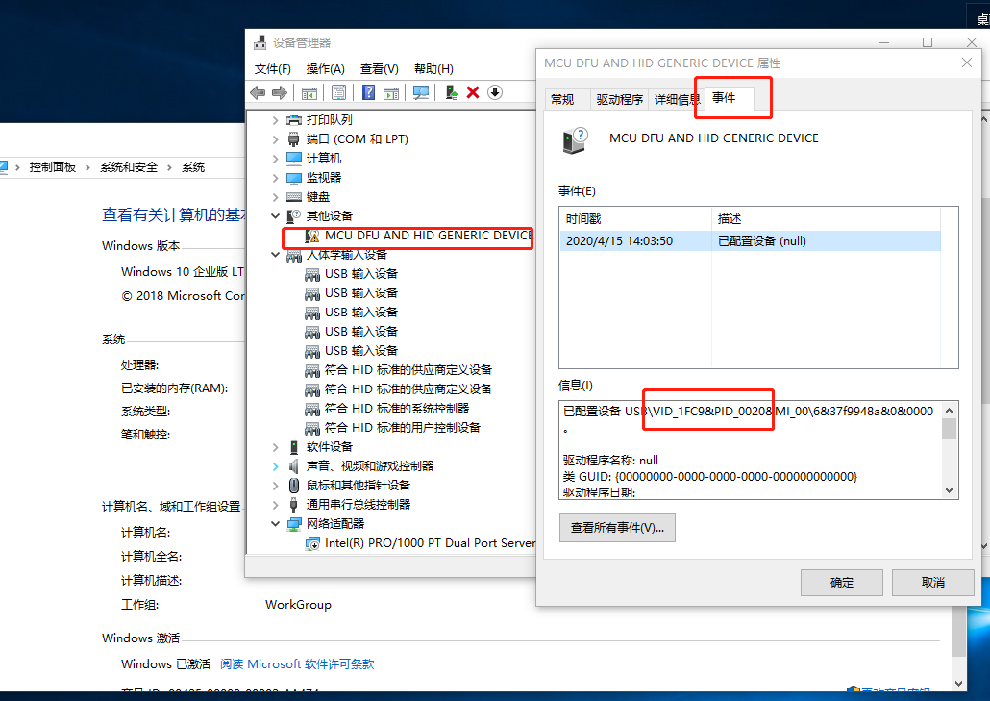

Find NXP-MCUBootUtility.exe from ….\NXP-MCUBootUtility-2.2.0\bin. Double-click to open it.

Download steps:

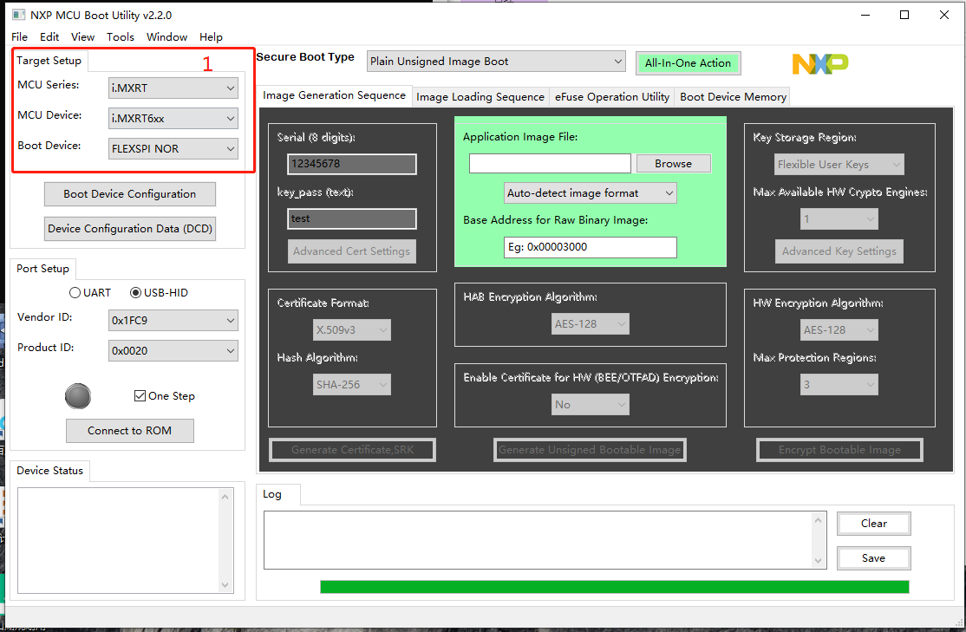

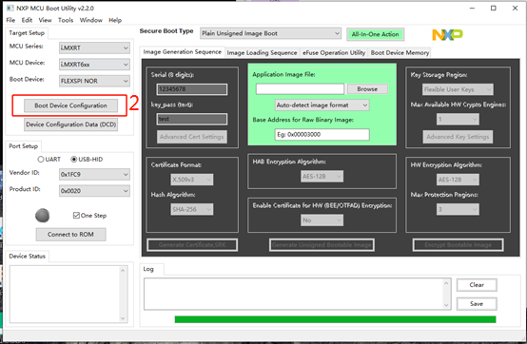

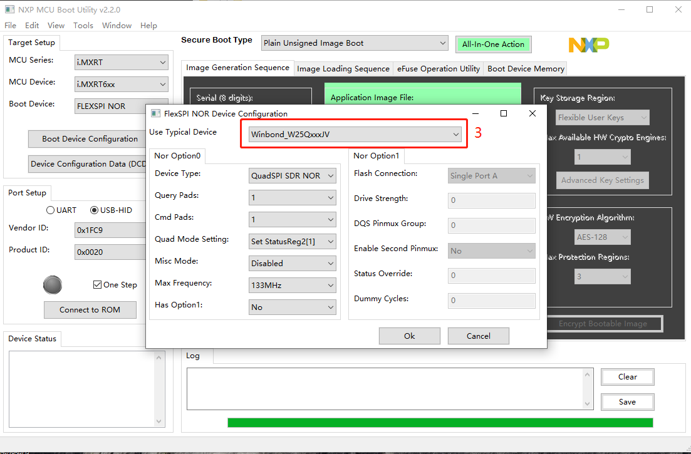

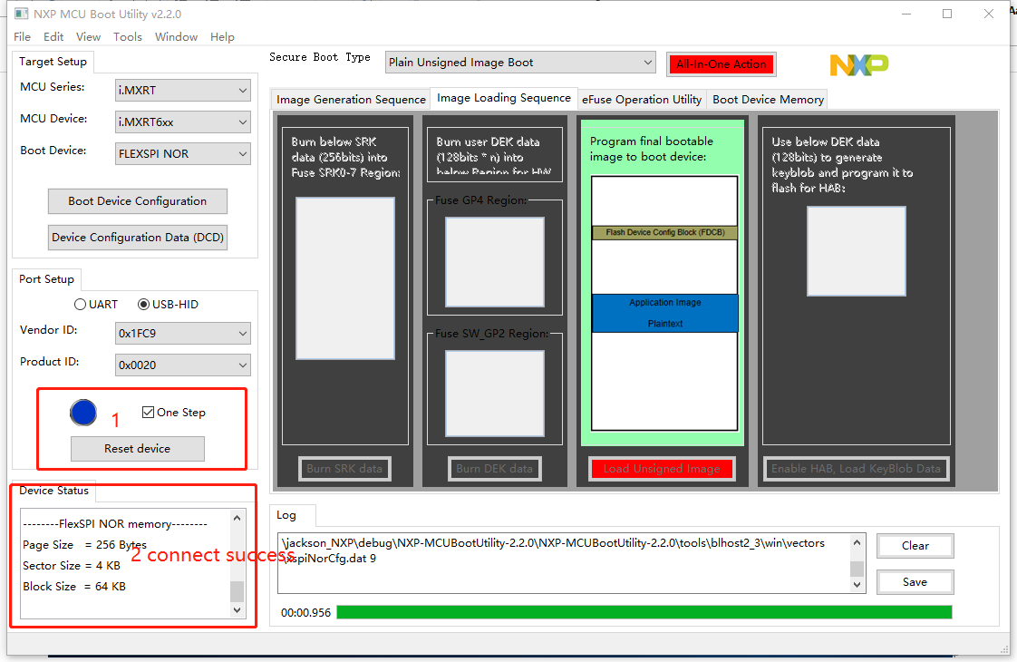

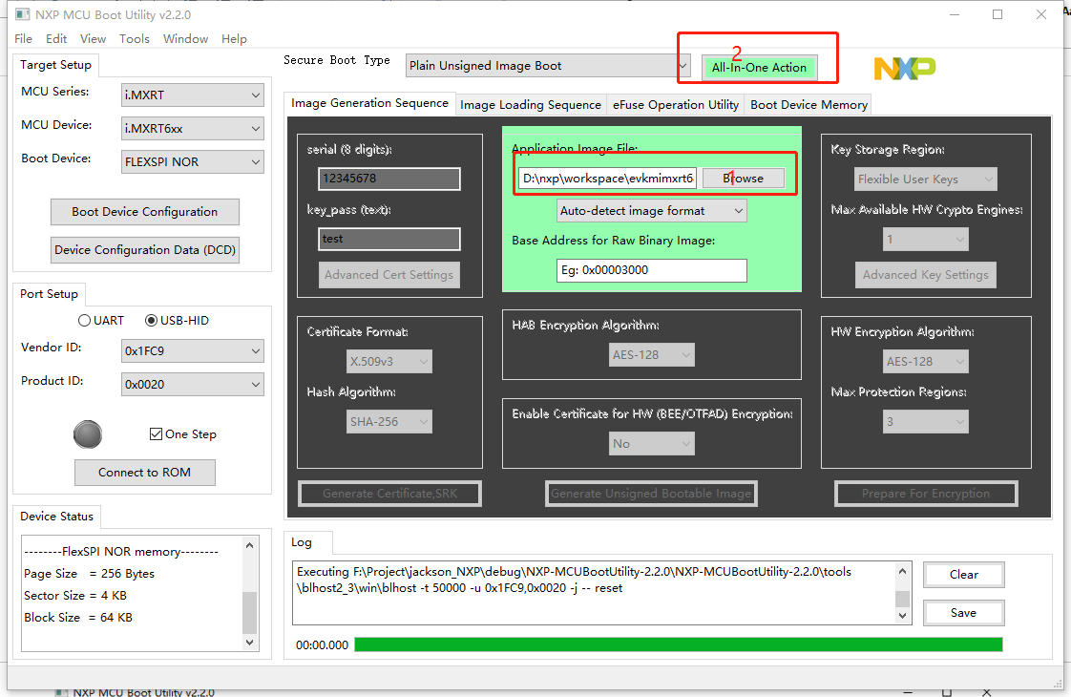

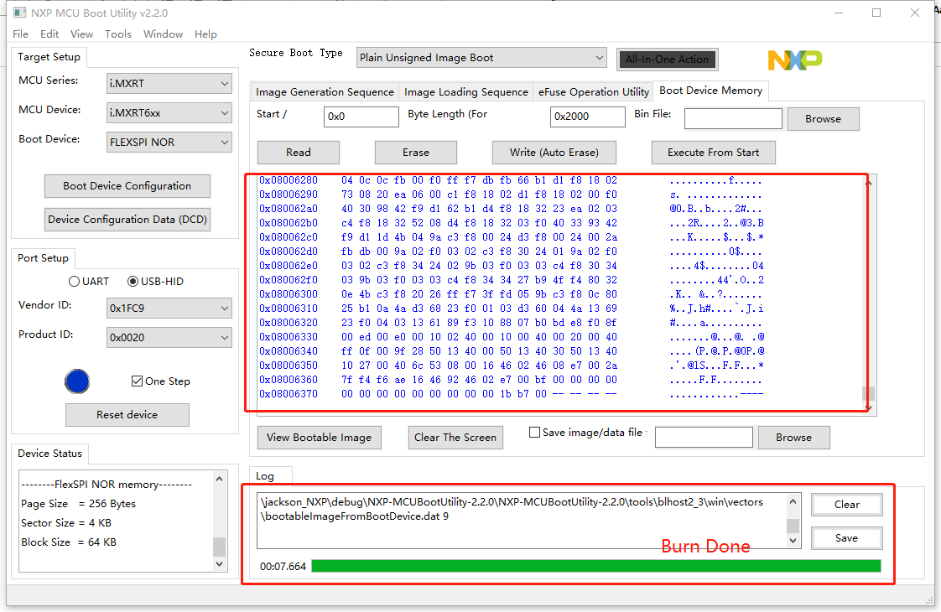

Step 3: Validation program started

1. ISP configure to 110, Because our board is connected to QSPI using Poat A.

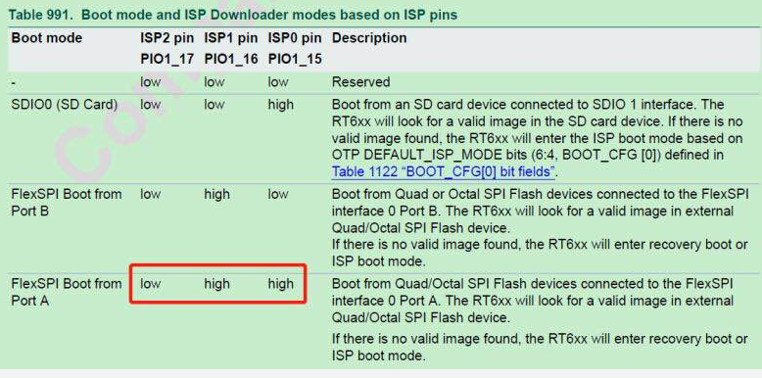

1. Connect to board TX,RX, GND using TTL USB serial port small board

Open the serial port tool and set the baud rate of 115200, Reset the mainboard. In the tool you will see "hello world"

